Assignment 2
War of the Ring (SPI, 1977)
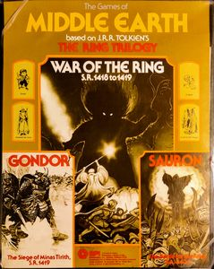

Assignment 2 War of the Ring February 9 Due: March 11 10%

Fantasy Wargames are “borderland genres”, they are hybrid descendents of two different kinds of games in terms of mechanics and milieu: Tabletop roleplaying games like D&D which are about characters in fantasy worlds, and historical wargames (or “simulations”) like Napoleon at Waterloo or Campaign for North Africa which are about historical generals and armies. Therefore you can compare a game like War of the Ring (and the battle games Sauron and Gondor) to either. At the same time, this game is a game “about” a narrative, an example of transmedia storytelling, an attempt to unshackle the characters and their world from a linear narrative and create an emergent system, a game, whilst retaining the elements of the original narrative (“the mythos”) so that the fans don’t come and harvest their organs.
This assignment is simple, though initially somewhat daunting: the rules set here is smaller than your average contemporary RPG like D&D but larger than a simple SPI wargame like Napoleon at Waterloo (In have posted the full rules for this game). Unlike other assignments, this one requires no technical component, though you may (should) take properly formatted screenshots to illustrate your points. It has no ethnographic component, no participant observation of game play (though of course that is possible but the difficult and time required to assemble the game from pdfs is immense). You simply must read the rules of the SPI game War of the Ring and at least one other game from those provided, inspect the components, and ask and answer some questions. That was worded precisely, you must formulate your own specific questions and answer them. One simple way to fail this assignment is to cut and paste any of the items below into your assignment, indeed, you are not even allowed to quote from this document. Use your words. You will not have to read all the rules as carefully, though it might be wise to do so. You should consider reading the designer’s notes at the end as well.
All materials for this assignment are posted at the bottom of the content page after Week 12 as a fantasy wargame rule library.
Screenshots: You can feel free to screenshot relevant bits of the rules to make your argument clear, following the strictures on screenshots of assignment 1. Again, improperly formatted screenshots or ones that are inserted into the text willy nilly are bad.
Format. As before, Title the assignment including the words “assignment 2”, then your name at top and centred, no student number no cover page. No introduction. Each question (there are exactly 5) is numbered, title is the question as you formulated it and is followed by paragraph of variable size and preceded by relevant screenshots which should be captioned so you can refer to them in the text. Screenshots must be real screenshots as in the first assignment and must be resized properly so as to not be super huge. No conclusions. You will quote the rules and cite them, you will quote the readings and lecture appropriately and relevantly and cite them.
This is a fantasy wargame: a form which stands on several borderlands between historical and fantasy game, between wargame and roleplaying game. So you will analyze these rules in the light of a wargame, particularly Kirschenbaum’s analysis of wargames and procedural granularity, and in the light of fantasy roleplaying games like D&D, using those readings and lectures (quote and cite), and in light of other course themes like games, narratives, characters, fantasy, and worlds.
The questions below are not the questions you will use, you will adapt the questions in a way that suits you and then answers them. Any cut and paste of the suggestions below is a zero on that section.
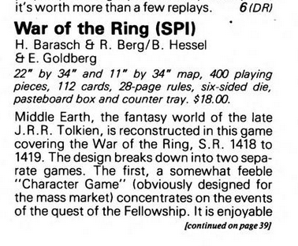
Here I will give you specific themes, devote a paragraph (which is a chunk of text of your choosing) to each, with screenshots and direct quotations from the rules. Citation style: SPI games are divided into lettered and numbered pargraphs so cite the game like so (WOTR E.2).
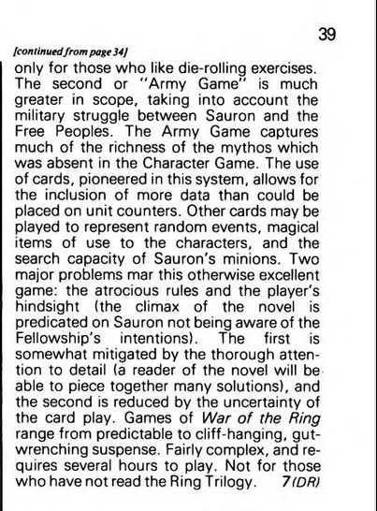
Review of WOTR from lecture and Ares Magazine 1.

- War of the Ring (WOTR) is a wargame
and can be compared to other historical or fantasy wargames in terms of core mechanics and procedural granularity. You know one wargame which consists almost entirely of core mechanics, Napoleon at Waterloo (though you are free to look at others, for example Sauron and Gondor). So compare some (at least one) comparable game core game system(s), explain similarities or differences with care. Bear in mind that WOTR is two games in one (the character game and the Army/campaign game) attend to similarities and differences of core mechanics here (and henceforth for all questions).
- War of the Ring (WOTR) is actually two games: a “character” game and an “army/campaign” game
The review adduced above thought very little of one of them. Compare the two games in the ways they differ in rules, focus, and approach and explain what some key differences are and why they are different including influences from other game types. Be very specific. You may use the above review but you must quote it if you do (review of WOTR, Ares Magazine 1: pages), but you must illustrate the point from the rules themselves. I will give one hint: the campaign game is pretty clearly indebted to the historical wargame genre in a way the character game is not: where does the character game draw its inspirations from.
- Game and Narrative
The designers of War of the Ring obviously wrestled with how to turn a well-known original narrative (which has only one outcome) into a playable game (which is an emergent game system (find term and cite), which has many possible outcomes) and (procedural granularity) capture the “richness of the mythos” (and worldness). What were the problems and attempted solitions? Be explicit, identify and explain the systems. What does the reviewer above feel about the relation between reading the book and playing the game is.
- This is a fantasy wargame, compare it to another fantasy wargame from this list.
Fantasy wargames are borderland forms between historical wargames and fantasy worlds. How and where do you bring the “fantasy” element into a fantasy wargame in each case. Be very specific.
These resources can be found on the content page after the Week 12 folder.
Compare WOTR (which can include Sauron and Gondor) to one of the following fantasy wargames, all of which are different variations on the fantasy theme both in terms of game mechanics, graphics, narratives and “world”:
Stafford’s White Bear Red Moon (1975) (AKA Dragon Pass) (Chaosium)
TSR’s Divine Right (1979, I have the 2024 version pdf)
SPI’s Sorceror (1975)
SPI’s Swords and Sorcery (1978)
SPI’s Barbarian Kings (1980)
SPI’s Citadel of Blood (1980) and Death Maze (1979) (in one merged document)
SPI’s Dragonslayer (1981)
Many of these games are given full reviews in the first issue of Ares magazine (1980), which would be a good resource.
There are two “borderlands” of fantasy here: one of them is the game borderland between the fantasy wargame and the fantasy RPG (D&D). Some of these are more obviously indebted to either D&D or War of the Ring, others simply emerge in the same borderland space between Tabletop RPGs and Wargame. A topic you are free to explore. Choose your own adventure.
- Fantasy games are set in, and portray, fantasy worlds
This is an expansion on the previous question, using the same or a different games. What is the relation of a fantasy narrative or game to a “constructed world”? How do constructed worlds afford “transmedia storytelling” (including games). How do different constructed game worlds afford emergent “fantasy” narratives. What even is “fantasy”? How do you enchant a constructed world? Here you can bring in specific examples from any of the games you discussed above, and everything you say must be grounded in the specifics of one or another game from the list, no vague swirling generalities.

